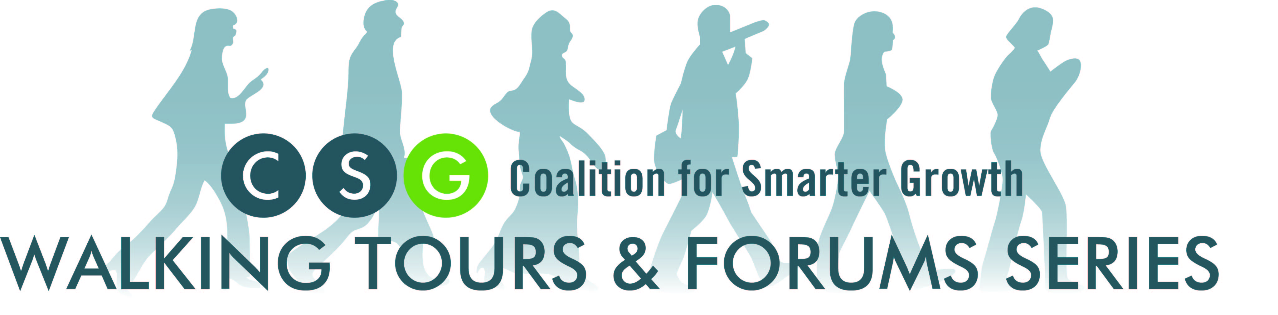
For upcoming events or to learn more about the
Walking Tours & Forums Series,
visit www.smartergrowth.net/events

The 2013 Walking Tours & Forums Series is made possible by the generous support of the National Association of Realtors.

Featuring

Chris Leinberger
Land use strategist, developer, researcher & author

David Bowers
Enterprise Community Partners

Ed Lazere
D.C. Fiscal Policy Institute

Walkable Neighborhoods: How to Make Them for Everyone
January 22, 2013
National Capital Planning Commission
Walkable urban places are in high demand.
A decade ago, Columbia Heights, H Street NE, and Petworth weren't considered particularly desirable places to live. Today, these neighborhoods are booming, and so are many more city blocks close to transit and downtown. In addition to the more established affluent neighborhoods, demand to live in newly-popular neighborhoods that offer walkable, bicycle-friendly, and transit-oriented lifestyles is driving up housing prices. Given the turnaround in 2000 of D.C.’s decades-long population decline, the city’s growth could be used to ensure that everyone - especially disadvantaged D.C. residents - shares in the benefits of a stronger city and stable tax base. But rising housing prices loom as an increasing problem for moderate- and low-income residents who want to stay in the city and take part in the District’s resurgence.
How can we continue to offer more opportunities to live in walkable, transit-oriented neighborhoods and share the benefits with people across the income spectrum?

About the Speakers
Chris Leinberger
Land use strategist, developer, researcher & author

Christopher B. Leinberger is a land use strategist, teacher, developer, researcher and author, balancing business realities with social and environmental concerns. His most recent Brookings Institution publication is: Walk This Way; The Economic Promise of Walkable Places in Metropolitan Washington, D.C.

Mr. Leinberger is:
- President of Locus; Responsible Real Estate Developers and Investors
- Nonresident Senior Fellow at Brookings Institution in Washington DC
- The Charles Bendit Distinguished Scholar and Research Professor, George Washington University School of Business
- Founding Partner of Arcadia Land Company, a New Urbanism and transit-oriented development firm
His most recent book is The Option of Urbanism, Investing in a New American Dream. He is the author of Strategic Planning for Real Estate Companies and has contributed chapters to 12 other books. Leinberger is a graduate of Swarthmore College and the Harvard Business School and lives in Dupont Circle in Washington, D.C.

David Bowers
Enterprise Community Partners
David Bowers is vice president and Mid-Atlantic market leader for Enterprise Community Partners. His work includes facilitating affordable housing and community development deals in collaboration with government agencies, lenders, for-profit and nonprofit developers in the Baltimore and Washington, D.C. metropolitan areas.

Enterprise’s Washington, D.C. office also participates with local coalitions advocating for increased resources for affordable housing and community development. Since coming to Enterprise in 2004, the company has provided more than $325 million in capital to support affordable housing efforts in the Washington, D.C. metropolitan area, creating or preserving more than 6,000 homes.

He currently serves as a board member of the Northern Virginia Affordable Housing Alliance, City First Enterprises, City First Homes, National Low Income Housing Coalition and Jubilee Housing.

Ed Lazere
D.C. Fiscal Policy Institute
Lazere has led the work of the DC Fiscal Policy Institute since it was established in 2001.
Prior to that, he was a policy analyst for 12 years at DCFPI’s parent organization, the Center on Budget and Policy Priorities. At CBPP, he worked on numerous issues at both the state and federal level, including state spending choices under the TANF block grant and other issues related to welfare reform implementation; state-level tax policy, particularly State Earned Income Tax Credits; and affordable housing.
Lazere holds a Master of Public Policy degree from the University of Maryland.

